**Name**: Francisco Izaguirre

**Course**: CSCI 4334

**Date**: 04/16/2025

**Instructor**: Wendy A. Sanchez Gomez

**Lab 05 – Manipulating Files and Directories in Linux**

***Introduction:***

This lab was focused on helping us get hands on experience with navigating and managing a Linux file system using the command line. The main objective was to build a better understanding of how Linux organizes its files, how user permissions work, and how to perform basic tasks like creating, copying , moving, deleting, and linking files. I practiced working within my own directories to safely manipulate files, and I explored system critical locations like /bin, /usr, /etc, /dev, and others to see where important files are stored. In addition to basic file operations, I also looked at symbolic and hard links, how device files work, and even tested what happens when you try to delete or view system level binaries. Overall, the lab was designed to make us more comfortable working directly with the Linux shell while also giving us a deeper understanding of how the OS is structured and maintained.

***Experimental Procedure:***

Step 1)

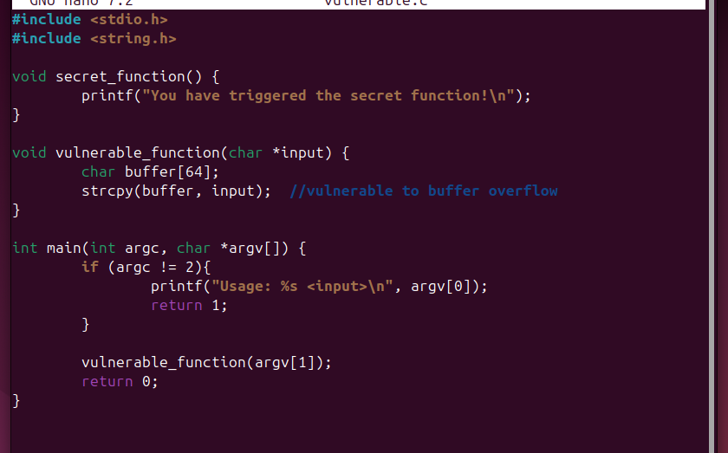



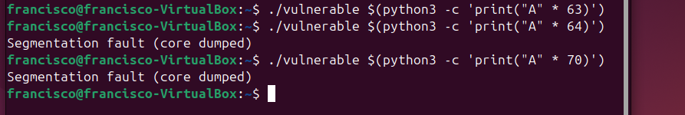

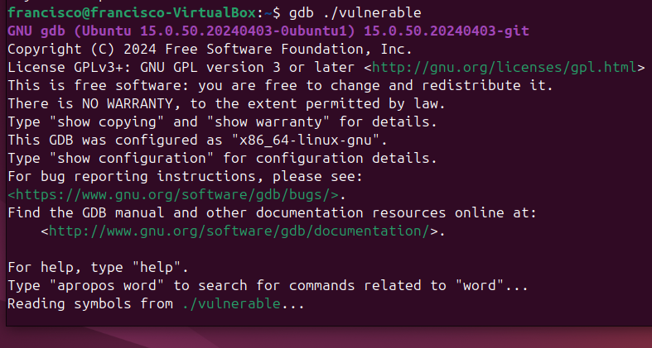

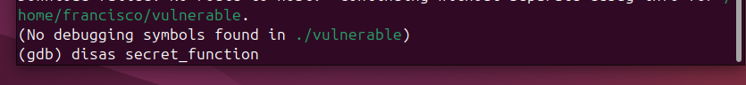

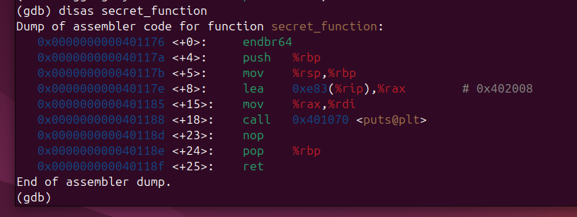

0x0000000000401176



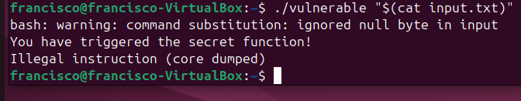



***Questions:***

1. **So why use these old command line programs? What are the advantages and disadvantages of using them?** Power and flexibility. While it is easy to perform simple file manipulations with a graphical file manager, complicated tasks can be easier with the command line programs. For example, how could we copy all the HTML files from one directory to another but copy only files that do not exist in the destination directory or are newer than the versions in the destination directory? It’s pretty hard with a file manager but pretty easy with the command line. (Slide 3)
2. **What is a wildcard in Linux?**

Because the shell uses filenames so much, it provides special characters to help you rapidly specify groups of filenames. These special characters are called wildcards. Using wildcards allows you to select filenames based on patterns of characters. (Slide 4)

1. **What are the differences between hard links and symbolic links?**

Hard links are the original Unix way of creating links, compared to symbolic links, which are more modern. A hard link is indistinguishable from the file itself. Unlike a symbolic link, when you list a directory containing a hard link, you will see no special indication of the link. When a hard link is deleted, the link is removed, but the contents of the file itself continue to exist (that is, its space is not deallocated) until all links to the file are deleted. (Slide 18)

1. **How does Linux abstract the network settings, the devices, the hard drives, etc.?**

In Linux, everything is a file. For example, the network settings are stored in a file. The devices like the hard drive, the printer are files on Linux. Upon installing Linux, you will find the file system is already populated with thousands of files and dozens of directories. The structure of these directories and files has been preestablished so that system administrators and users alike can learn where to find important files. (Slide 41)

1. **Name 5 Linux top-level directories.**

/bin, /boot, /dev, /etc, /home, /lib (Slide 42)

1. **What is the difference between /bin and /sbin directories and /usr/bin and /usr/sbin directories?**

/bin stores ESSENTIAL user executable programs while /sbin also has ESSENTIAL executables but are typically used system administrators not users. /usr/bin contains NON ESSENTIAL user commands while /usr/sbin contains NON ESSSENTIAL system binaries for system administrators.

***Conclusion:***

The goal of this lab was to help us understand the structure of a Linux system and how to interact with it through the command line. By the end, I had practiced a wide range of essential skills, including navigating directories, manipulating files and folders, creating users, and exploring key areas of the system like /boot, /dev, and /etc. I also got to work with different types of links, inspect system files, and understand how Linux handles permissions and device files. Overall the lab helped reinforce the idea that everything in Linux is treated as a file, and that many administrative tasks can be done efficiently from the terminal. Practicing these steps made me feel more confident using the shell and gave me a solid understanding and foundation for more advanced Linux topics going forward.

**References:**

Sanchez, Wendy. CYBI 3345 – *Operating Systems and Security*

*CSCI 4334 – Operating Systems File System*. 16 Apr. 2025. (PowerPoint).